CERTIFICATE

This is to certify that Vani Chitkara of Class XII-B has prepared the report on the project “Railway Reservation System”. The report is the result of her efforts & endeavors. The report is found worthy of acceptance as final project report for the subject Computer Science of Class XII. She has prepared the report under my guidance.

_________________

Signature

ACKNOWLEDEGMENT

I would like to express a deep sense of thanks & gratitude to my project guide for guiding me immensely through the course of the project. She always evinced keen interest in my work. Her constructive advice & constant motivation have been responsible for the successful completion of this project.

I also thank my parents for their motivation & support. I thank my classmates for their timely help & support for compilation of this project.

Last but not the least, I would like to thank all those who have helped directly or indirectly towards the completion of this project.

Vani Chitkara

XII-B

INDEX

|  |  |  |
| --- | --- | --- |
| S.NO. | TOPIC | |
| 1 | INTRODUCTION | |
| 2 | OBJECTIVE | |
| 3 | METHODOLOGY | |
|  | 3.1 | HEADER FILES USED |
|  | 3.2 | FILES GENERATED |
|  | 3.3 | WORKING DESCRIPTION |
| 4 | REQUIREMENTS TO RUN THE SOFTWARE | |
|  | 4.1 | MINIMUM HARDWARE REQUIREMENT |
|  | 4.2 | MINIMUM SOFTWARE REQUIREMENT |
| 5 | PROGRAM SOURCE CODE | |
| 6 | OUTPUT SCREENS | |
| 7 | FUTURE SCOPE OF THE PROGRAM | |
| 8 | BIBLIOGRAPHY | |

INTRODUCTION

This project introduces railway ticket reservation system. It explains how reservation is being done in Indian Railways. The whole process is explained step by step. This project is developed in C++ language. Many header files are used in this project. Various functions, structures and classes have been used to make complete use of features offered by the C++ language. Proper comments have been given at desired locations, to make the project user friendly.

OBJECTIVE

To develop a C++ project to manage railway ticket reservation system using object oriented programming and data file handling.

METHODOLOGY

HEADER FILES USED

1. FSTREAM.H – for file handling
2. IOMANIP.H – for using manipulators
3. CONIO.H – for clrscr() and getch() functions
4. STDIO.H – for standard I/O operations
5. STRING.H – for handling strings
6. TIME.H – for using time related functions
7. STDLIB.H – for handling exit function
8. IOSTREAM.H – for handling cin and cout

FILES GENERATED

1. TEXT FILES – a) T.TXT

b) P.TXT

c) CN.TXT

d) ID.TXT

2. PROGRAM FILE – RAILWAYS.CPP

WORKING DESCRIPTION

This program is used to keep reservation record and passenger record.

This program consists of the following options:

1. Admin Mode:
2. To create, add and display train details.
3. To manage users: create, add and display user details.
4. To display passenger details.
5. To return to the main menu.
6. User Mode:
7. To reserve train tickets.
8. To cancel train tickets.
9. Train enquiry.
10. To return to main menu.

REQUIREMENTS TO RUN THE SOFTWARE

MINIMUM HARDWARE REQUIREMENT

Turbo C++ runs on the IBM PC family of computers, including the XT, AT and PS/2 along with all true IBM compatibilities.

Turbo C++ requires DOS 2.0 or higher and at least 640KB memory. It runs on any 80 column monitor. The minimum requirement is a hard disk drive and RAM.

MINIMUM SOFTWARE REQUIREMENT

Operating System MS DOS 6.22 Turbo C++ compiler.

The program file and the text files.

SOURCE CODE

//***************************************************************

// HEADER FILE USED IN PROJECT

//****************************************************************

#include<stdio.h>

#include<conio.h>

#include<stdlib.h>

#include<string.h>

#include<iostream.h>

#include<time.h>

#include<iomanip.h>

#include<fstream.h>

//***************************************************************

// GLOBAL DECLARATION OF VARIABLES

//****************************************************************

char f[10]="f",s[10]="s";

int addr,ad,f1,d,m,i,amt,flag=1;

float tamt;

//***************************************************************

// CLASS USED FOR USER LOGIN DETAILS

//****************************************************************

class login

{

public:

char id[100],pass[100];

void getid()

{

cout<<"Enter your Id:";

gets(id);

cout<<"Enter the password";

gets(pass);

}

void displayid()

{

cout<<"Id:";

puts(id);

cout<<"Password:";

puts(pass);

}

};

//***************************************************************

// CLASS USED FOR TRAIN DETAILS

//****************************************************************

class detail

{

public:

int tno,c1,c1fare,c2,c2fare,d,m,y;

char tname[100],bp[100],dest[100];

void getdetail()

{

cout<<"Enter the details as follows:\n";

cout<<"Train no:"<<endl;

cin>>tno;

cout<<"Train name:"<<endl;

gets(tname);

cout<<"Boarding point:"<<endl;

gets(bp);

cout<<"Destination pt:"<<endl;

gets(dest);

cout<<"No of seats in first class & fare per ticket:"<<endl;

cin>>c1>>c1fare;

cout<<"No of seats in second class & fare per ticket:"<<endl;

cin>>c2>>c2fare;

cout<<"Date of travel:"<<endl;

cin>>d>>m>>y;

}

void displaydetail()

{ cout<<"========================================================================\n";

cout<<"T.NO.\t\TNAME\t\BP\tDEST\tC1\tC1FARE\tC2\tC2FARE\tD-M-Y \n";

cout<<"========================================================================\n";

cout<<tno<<"\t"<<tname<<"\t"<<bp<<"\t"<<dest<<"\t";

cout<<c1<<"\t"<<c1fare<<"\t"<<c2<<"\t"<<c2fare<<"\t";

cout<<d<<"-"<<m<<"-"<<y<<"\t"<<endl;

}

};

//***************************************************************

// CLASS USED FOR TICKET RESERVATION

//****************************************************************

class reser

{

public:

int pnr,tno,nosr,i,d,m,y,con,age[20];

char tname[100],bp[10],dest[100],pname[10][100],clas[10];

float amc;

void getresdet();

void displayresdet();

};

void reser::getresdet()

{

cout<<"Enter the details as follows:\n";

cout<<"Train no:"<<endl;

cin>>tno;

cout<<"Train name:"<<endl;

gets(tname);

cout<<"Boarding point:"<<endl;

gets(bp);

cout<<"Destination point:"<<endl;

gets(dest);

cout<<"No of seats required:"<<endl;

cin>>nosr;

for(i=0; i<nosr ; i++)

{

cout<<"Passenger name:"<<endl;

gets(pname[i]);

cout<<"Passenger age:"<<endl;

cin>>age[i];

}

cout<<"Enter the class f-first class s-second class:"<<endl;

gets(clas);

cout<<"Date of travel:"<<endl;

cin>>d>>m>>y;

cout<<"Enter the concession category\n";

cout<<"1.Military\n2.Senior citizen\n";

cout<<"3.Children below 5 yrs\n4.None\n";

cin>>con;

cout<<"............END OF GETTING DETAILS............\n";

}

void reser::displayresdet()

{ clrscr();

cout<<"...............................................\n";

cout<<"...............................................\n";

cout<<"Pnr no:"<<pnr;

cout<<"\nTrain no:"<<tno;

cout<<"\nTrain name:";

puts(tname);

cout<<"Boarding point:";

puts(bp);

cout<<"Destination point:";

puts(dest);

cout<<"No of seats reserved:"<<nosr<<endl;

for(i=0; i<nosr; i++)

{

cout<<"Passenger name:";

puts(pname[i]);

cout<<"Passenger age:"<<age[i]<<endl;

}

cout<<"Your class:";

puts(clas);

cout<<"Date of reservation:"<<d<<"-"<<m<<"-"<<y;

cout<<"\nYour concession category:"<<con;

cout<<"\nYou must pay:"<<amc<<endl;

cout<<"***********************************************\n";

cout<<".........END OF RESERVATION.................\n";

cout<<"***********************************************\n";

}

//***************************************************************

// CLASS USED FOR TICKET CANCELLATION

//****************************************************************

class canc

{

public:

int pnr,tno,age[20],i,nosc,d,m,y;

char tname[100],bp[10],dest[10],pname[10][100],clas[10];

float amr;

void getcancdet()

{

cout<<"Enter the details as follows:\n";

cout<<"Pnr no:"<<endl;

cin>>pnr;

cout<<"Date of cancellation:"<<endl;

cin>>d>>m>>y;

cout<<"...........END OF GETTING DETAILS...........\n";

}

void displaycancdet();

};

void canc:: displaycancdet()

{

cout<<"...........................................\n";

cout<<"...........................................\n";

cout<<"Pnr no:"<<pnr;

cout<<"\nTrain no:"<<tno;

cout<<"\nTrain name:";

puts(tname);

cout<<"Boarding point:";

puts(bp);

cout<<"Destination pt:";

puts(dest);

cout<<"Your class:";

puts(clas);

cout<<"no of seats to be cancelled:"<<nosc<<endl;

for(i=0; i<nosc; i++)

{

cout<<"Passenger name:";

puts(pname[i]);

cout<<"passenger age:"<<age[i];

}

cout<<"\nDate of cancellation:"<<d<<"-"<<m<<"-"<<y;

cout<<"\nYou can collect:"<<amr<<"rs"<<endl;

cout<<"*****************************************\n";

cout<<".........END OF CANCELLATION.............\n";

cout<<"*****************************************\n";

}

//***************************************************************

// FUNCTION DECLARATION

//****************************************************************

void manage();

void intro();

void can();

void user();

void database();

void res();

void reserve();

void displaypassdetail();

void cancell();

void enquiry();

//***************************************************************

// THE MAIN FUNCTION OF PROGRAM

//****************************************************************

void main()

{

clrscr();

intro();

int ch;

do

{

clrscr();

cout<<"~~~~~~~~~~~~~~~~~~~~~~~~~~~~~~~~~~~~~~~~~~~~~~~~~~~\n";

cout<<".......WELCOME TO RAILWAY RESERVATION SYSTEM.......\n";

cout<<"~~~~~~~~~~~~~~~~~~~~~~~~~~~~~~~~~~~~~~~~~~~~~~~~~~~\n";

cout<<"^^^^^^^^^^^^^^^^^^^^^MAIN MENU^^^^^^^^^^^^^^^^^^^^^\n";

cout<<"1.Admin mode\n2.User mode\n3.Exit\n";

cout<<"Enter your choice:"<<endl;

cin>>ch;

cout<<endl;

switch(ch)

{

case 1:

database();

break;

case 2:

user();

break;

case 3:

exit(0);

}

}

while(ch<=3);

getch();

}

//***************************************************************

// INTRODUCTION FUNCTION

//****************************************************************

void intro()

{

clrscr();

gotoxy(29,11);

cout<<"RAILWAYS MANAGEMENT";

gotoxy(15,14);

cout<<"TICKET RESERVATION, CANCELLATION AND TRAIN ENQUIRY";

gotoxy(35,17);

cout<<"PROJECT";

cout<<"\n\nMADE BY: VANI CHITKARA";

cout<<"\n\nSCHOOL : D.L.D.A.V MODEL SCHOOL";

getch();

}

//***************************************************************

// ADMINISTRATOR MENU FUNCTION

//****************************************************************

void database()

{

char password[100]="code";

char pass[100];

cout<<"Enter the admininistrator password:";

cin>>pass;

detail a;

fstream f;

int ch;

char c;

if(strcmp(pass,password)!=0)

{

cout<<"Enter the password correctly \n";

cout<<"You are not permitted to logon this mode\n";

goto h;

}

if(strcmp(pass,password)==0)

{

char c;

do

{

cout<<"...........ADMINISTRATOR MENU...........\n";

cout<<"1.Create detail data base\n2.Add details\n";

cout<<"3.Display details\n4.User management\n";

cout<<"5.Display passenger details\n6.Return to main menu\n";

cout<<"Enter your choice:";

cin>>ch;

cout<<endl;

switch(ch)

{

case 1:

f.open("t.txt",ios::out|ios::binary);

do

{

a.getdetail();

f.write((char *) & a,sizeof(a));

cout<<"Do you want to add one more record?\n";

cout<<"y-for Yes\nn-for No\n";

cin>>c;

}

while(c=='y');

f.close();

break;

case 2:

f.open("t.txt",ios::in|ios::out|ios::binary|ios::app);

a.getdetail();

f.write((char *) & a,sizeof(a));

f.close();

break;

case 3:

f.open("t.txt",ios::in|ios::out|ios::binary|ios::app);

f.seekg(0);

while(f.read((char *) & a,sizeof(a)))

{

a.displaydetail();

}

f.close();

break;

case 4:

manage();

break;

case 5:

displaypassdetail();

break;

}

}

while(ch<=5);

f.close();

}

h:

}

//***************************************************************

// USER TICKET RESERVATION MENU

//****************************************************************

void reserve()

{

int ch;

do

{

cout<<"1.Reserve\n2.Return to the main menu\n";

cout<<"Enter your choice:";

cin>>ch;

cout<<endl;

switch(ch)

{

case 1:

res();

break;

}

}

while(ch==1);

getch();

}

//***************************************************************

// FUNCTION FOR TICKET RESERVATION

//****************************************************************

void res()

{

detail a;

reser b;

fstream f1,f2;

time_t t;

f1.open("t.txt",ios::in|ios::out|ios::binary);

f2.open("p.txt",ios::in|ios::out|ios::binary|ios::app);

int ch;

b.getresdet();

while(f1.read((char *) &a,sizeof(a)))

{

if(a.tno==b.tno)

{

if(strcmp(b.clas,f)==0)

{

if(a.c1>=b.nosr)

{

amt=a.c1fare;

addr=f1.tellg();

ad=sizeof(a.c1);

f1.seekp(addr-(7*ad));

a.c1=a.c1-b.nosr;

f1.write((char *) & a.c1,sizeof(a.c1));

if(b.con==1)

{

cout<<"Concession category:MILITARY PERSONNEL\n";

b.amc=b.nosr*((amt*50)/100);

}

else if(b.con==2)

{

cout<<"Concession category:SENIOR CITIZEN\n";

b.amc=b.nosr*((amt*60)/100);

}

else if(b.con==3)

{

cout<<"Concession category:CHILDERN BELOW FIVE\n";

b.amc=0.0;

}

else if(b.con==4)

{

cout<<"You cannot get any concession\n";

b.amc=b.nosr*amt;

}

srand((unsigned) time(&t));

b.pnr=rand();

f2.write((char *) & b,sizeof(b));

b.displayresdet();

cout<<"------------------------------------------------------\n";

cout<<"--------------Your ticket is reserved-----------\n";

cout<<"-----------------End of reservation menu-------\n";

}

else

{

cout<<"**********Sorry req seats not available********\n";

}

}

else if(strcmp(b.clas,s)==0)

{

if(a.c2>=b.nosr)

{

amt=a.c2fare;

addr=f1.tellg();

ad=sizeof(a.c2);

f1.seekp(addr-(5*ad));

a.c2=a.c2-b.nosr;

f1.write((char *) & a.c2,sizeof(a.c2));

if(b.con==1)

{

cout<<"Concession category:MILITARY PRESONNEL\n";

b.amc=b.nosr*((amt*50)/100);

}

else if(b.con==2)

{

cout<<"Concession category:SENIOR CITIZEN\n";

b.amc=b.nosr*((amt*60)/100);

}

else if(b.con==3)

{

cout<<"Concession category:CHILDERN BELOW FIVE\n";

b.amc=0.0;

}

else if(b.con==4)

{

cout<<"You cannot get any concession\n";

b.amc=b.nosr*amt;

}

f2.write((char *) & b,sizeof(b));

b.displayresdet();

cout<<"---------------------------------------\n";

cout<<"--------Your ticket is reserved--------\n";

cout<<"------------End of reservation---------\n";

}

else

{

cout<<"********Sorry req no of seats not available*******\n";

}

}

getch();

goto h;

}

else

{

flag=0;

}

}

if(flag==0)

{

cout<<"............Wrong train no......................\n";

cout<<"......Enter the train no from the data base.....\n";

}

f1.close();

f2.close();

getch();

h:

}

//***************************************************************

// FUNCTION TO DISPLAY PASSENGER DETAILS

//****************************************************************

void displaypassdetail()

{

fstream f;

reser b;

f.open("p.txt",ios::in|ios::out|ios::binary);

f.seekg(0);

while(f.read((char *) & b,sizeof(b)))

{

b.displayresdet();

}

f.close();

getch();

}

//***************************************************************

// FUNCTION FOR TRAIN ENQUIRY

//****************************************************************

void enquiry()

{

fstream f;

f.open("t.txt",ios::in|ios::out|ios::binary);

detail a;

while(f.read((char *) & a,sizeof(a)))

{

a.displaydetail();

}

getch();

}

//***************************************************************

// FUNCTION FOR TICKET CANCELLATION

//****************************************************************

void cancell()

{

detail a;

reser b;

canc c;

fstream f1,f2,f3;

f1.open("t.txt",ios::in|ios::out|ios::binary);

f2.open("p.txt",ios::in|ios::out|ios::binary);

f3.open("cn.txt",ios::in|ios::out|ios::binary);

cout<<"**********CANCELLATION MENU*********\n";

c.getcancdet();

while(f2.read((char *) & b,sizeof(b)))

{

if(b.pnr==c.pnr)

{

c.tno=b.tno;

strcpy(c.tname,b.tname);

strcpy(c.bp,b.bp);

strcpy(c.dest,b.dest);

c.nosc=b.nosr;

for(int j=0; j<c.nosc; j++)

{

strcpy(c.pname[j],b.pname[j]);

c.age[j]=b.age[j];

}

strcpy(c.clas,b.clas);

if(strcmp(c.clas,f)==0)

{

while(f1.read((char *) & a,sizeof(a)))

{

if(a.tno==c.tno)

{

a.c1=a.c1+c.nosc;

d=a.d;

m=a.m;

addr=f1.tellg();

ad=sizeof(a.c1);

f1.seekp(addr-(7*ad));

f1.write((char *) & a.c1,sizeof(a.c1));

tamt=b.amc;

if((c.d==d)&&(c.m==m))

{

cout<<"You are cancelling at the date of departure\n";

c.amr=tamt-((tamt*60)/100);

c.displaycancdet();

}

else if(c.m==m)

{

cout<<"You are cancelling at the month of departure\n";

c.amr=tamt-((tamt*50)/100);

c.displaycancdet();

}

else if(m>c.m)

{

cout<<"You are cancelling one month before the date of departure\n";

c.amr=tamt-((tamt*20)/100);

c.displaycancdet();

}

else

{

cout<<"Cancelling after the departure\n";

cout<<"Your request cannot be completed\n";

}

}

}

}

else if(strcmp(c.clas,s)==0)

{

while(f1.read((char *) & a,sizeof(a)))

{

if(a.tno==c.tno)

{

a.c2=a.c2+c.nosc;

d=a.d;

m=a.m;

addr=f1.tellg();

ad=sizeof(a.c2);

f1.seekp(addr-(5*ad));

f1.write((char *) & a.c2,sizeof(a.c2));

tamt=b.amc;

if((c.d==d)&&(c.m==m))

{

cout<<"You are cancelling at the date of departure\n";

c.amr=tamt-((tamt*60)/100);

c.displaycancdet();

}

else if(c.m==m)

{

cout<<"You are cancelling at the month of departure\n";

c.amr=tamt-((tamt*50)/100);

c.displaycancdet();

}

else if(m>c.m)

{

cout<<"You are cancelling one month before the date of departure\n";

c.amr=tamt-((tamt*20)/100);

c.displaycancdet();

}

else

{

cout<<"Cancelling after the departure\n";

cout<<"Your request cannot be completed\n";

c.displaycancdet();

}

}

}

}

}

else

{

flag=0;

goto m;

}

}

m:

if(flag==0)

{

cout<<"Enter the correct pnr no\n";

}

f1.close();

f2.close();

f3.close();

getch();

}

//***************************************************************

// USER TICKET CANCELLATION MENU

//****************************************************************

void can()

{

int ch;

do

{

cout<<".................CANCELLATION MENU.........\n";

cout<<"1.Cancel\n2.Return to the main menu\n";

cout<<"Enter your choice:";

cin>>ch;

cout<<endl;

switch(ch)

{

case 1:

cancell();

break;

}

}

while(ch==1);

getch();

}

//***************************************************************

// USER MENU FUNCTION

//****************************************************************

void user()

{

login a;

int ch;

cout<<"*****************************************************\n";

cout<<"**************WELCOME TO THE USER MENU***************\n";

cout<<"*****************************************************\n";

char password[100];

fstream f;

f.open("id.txt",ios::in|ios::out|ios::binary);

char id[100];

puts("Enter your id:");

gets(id);

puts("Enter your password:");

gets(password);

while(f.read((char *) & a,sizeof(a)))

{

if((strcmp(a.id,id)==0)&&(strcmp(a.pass,password)==0))

{

do

{

cout<<"1.Reserve\n2.Cancel\n3.Enquiry\n4.Return to the main menu\n";

cout<<"Enter your choice:";

cin>>ch;

cout<<endl;

switch(ch)

{

case 1:

reserve();

break;

case 2:

can();

break;

case 3:

enquiry();

break;

}

}

while(ch<=3);

goto j;

}

else

{

d=1;

}

}

if(d==1)

{

cout<<"Enter your user id and password correctly\n";

}

getch();

j:

}

//***************************************************************

// ADMINISTRATOR USER MANAGEMENT MENU

//****************************************************************

void manage()

{

int ch;

fstream f;

char c;

login a;

cout<<".........WELCOME TO THE USER MANAGEMENT MENU........\n";

do

{

cout<<"1.Create id data base\n2.Add details\n";

cout<<"3.Display details\n4.Return to the main menu\n";

cout<<"Enter your choice:";

cin>>ch;

cout<<endl;

switch(ch)

{

case 1:

f.open("id.txt",ios::out|ios::binary);

do

{

a.getid();

f.write((char *) & a,sizeof(a));

cout<<"Do you want to add one more record\n";

cout<<"y-Yes\nn-No\n";

cin>>c;

}

while(c=='y');

f.close();

break;

case 2:

f.open("id.txt",ios::in|ios::out|ios::binary|ios::app);

a.getid();

f.write((char *) & a,sizeof(a));

f.close();

break;

case 3:

f.open("id.txt",ios::in|ios::out|ios::binary);

f.seekg(0);

while(f.read((char *) & a,sizeof(a)))

{

a.displayid();

}

f.close();

break;

}

}

while(ch<=3);

getch();

}

//***************************************************************

// END OF PROJECT

//***************************************************************

OUTPUT SCREENS

1. 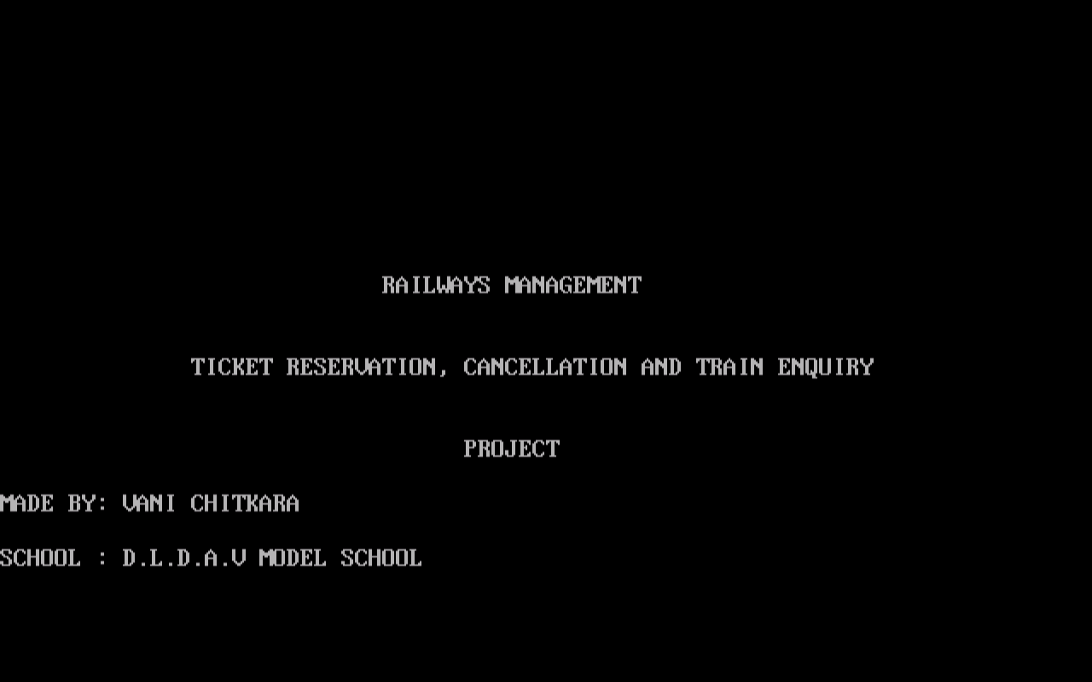WELCOME SCREEN

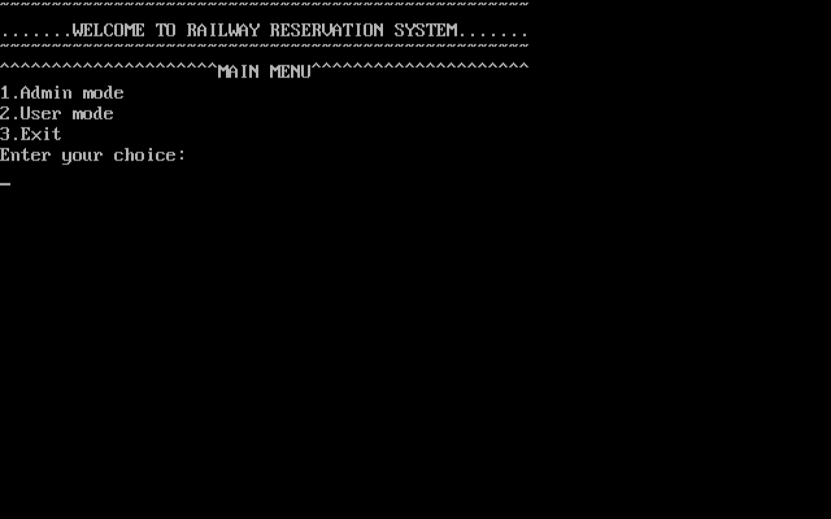

1. CREATE/ADD NEW TRAIN DETAILS

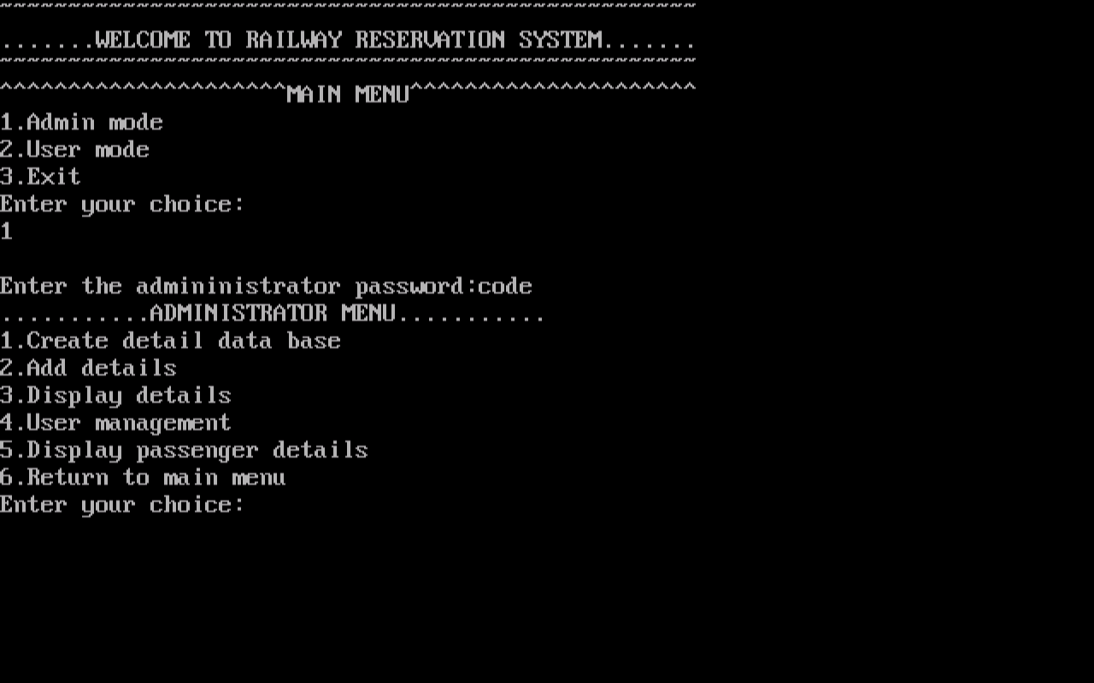

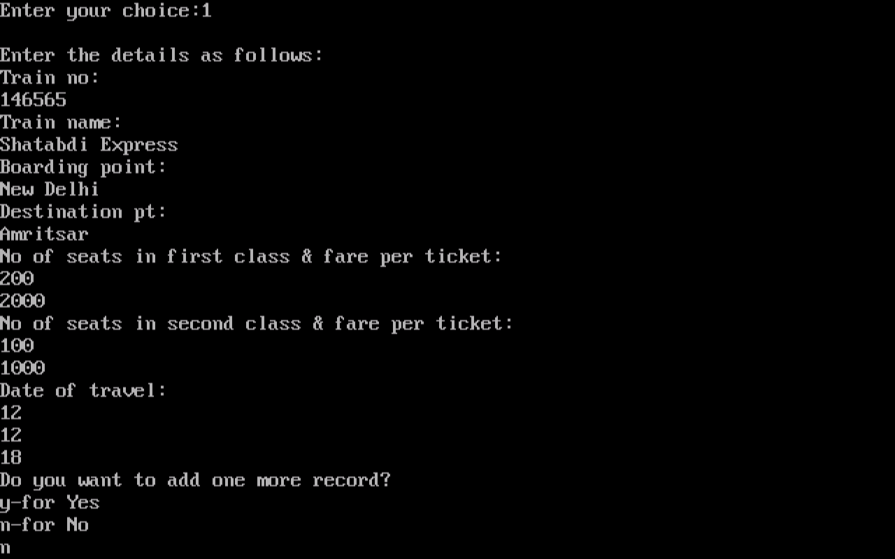

1. DISPLAY TRAIN DETAILS

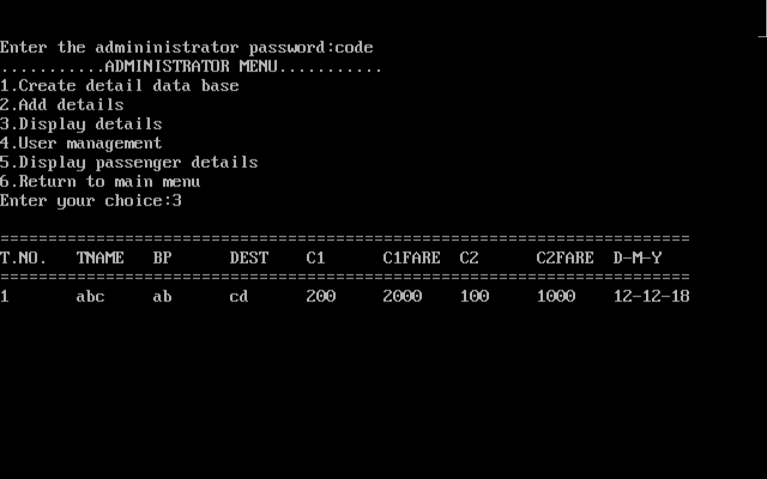

1. ADMIN MODE: USER MANAGEMENT MENU

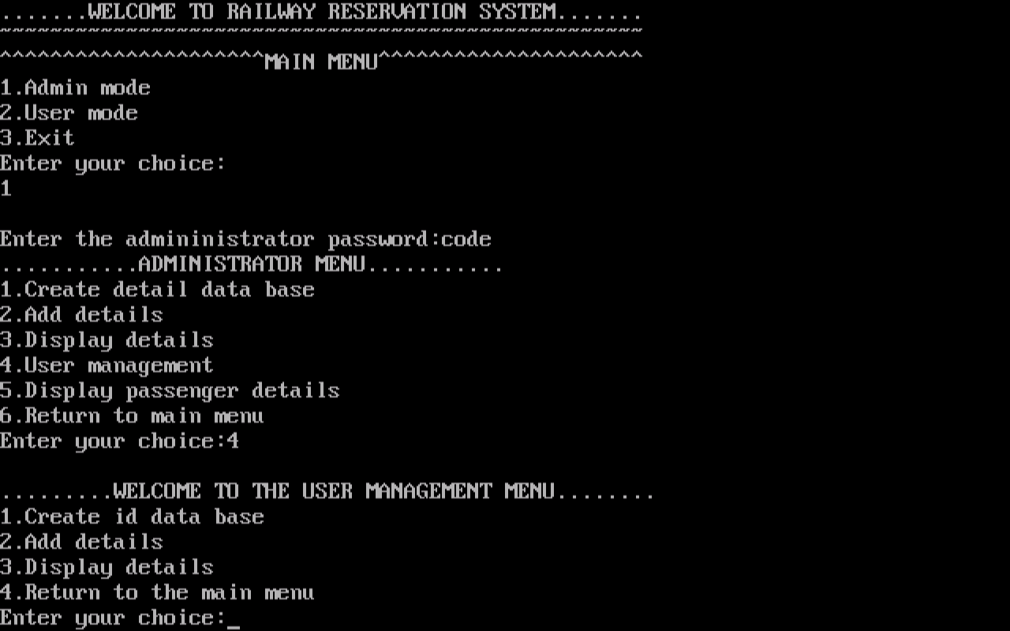

1. CREATE/ADD USER DETAILS

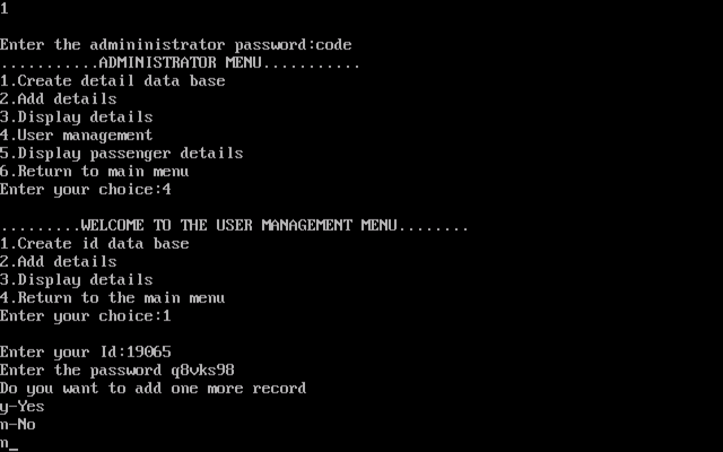

1. DISPLAY USER DETAILS

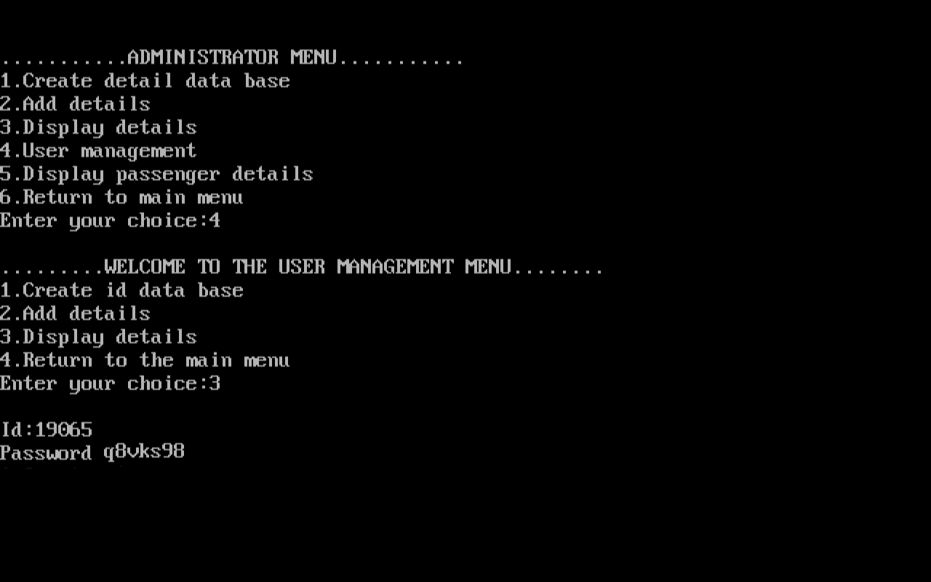

1. DISPLAY PASSENGER DETAILS

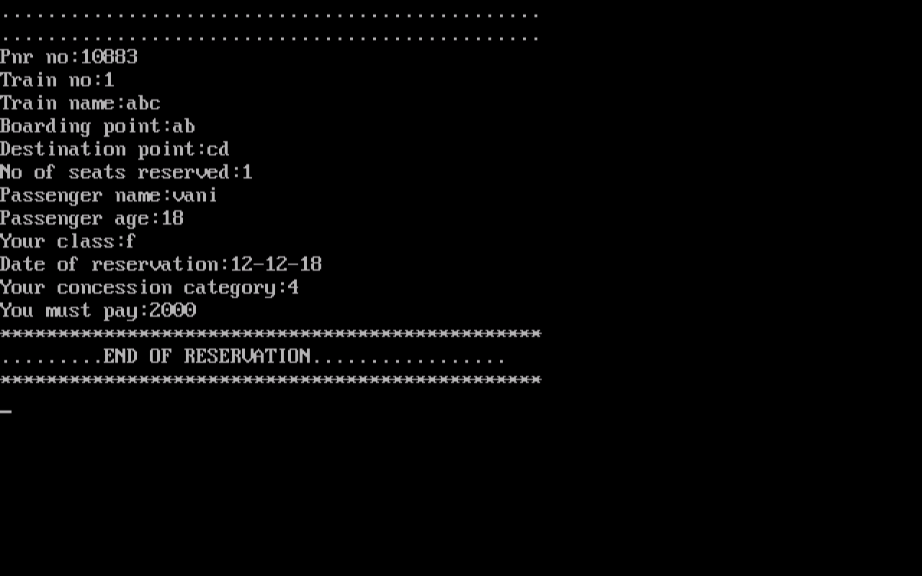

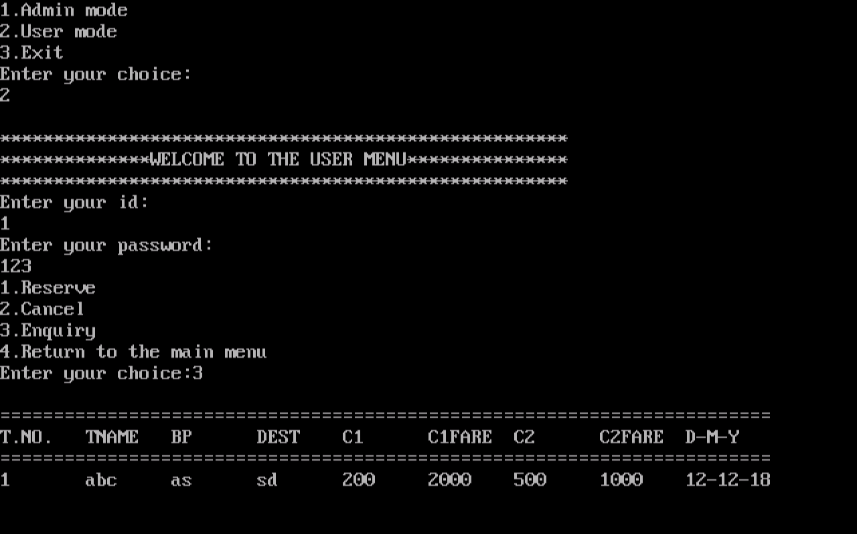

1. RESERVE TICKET

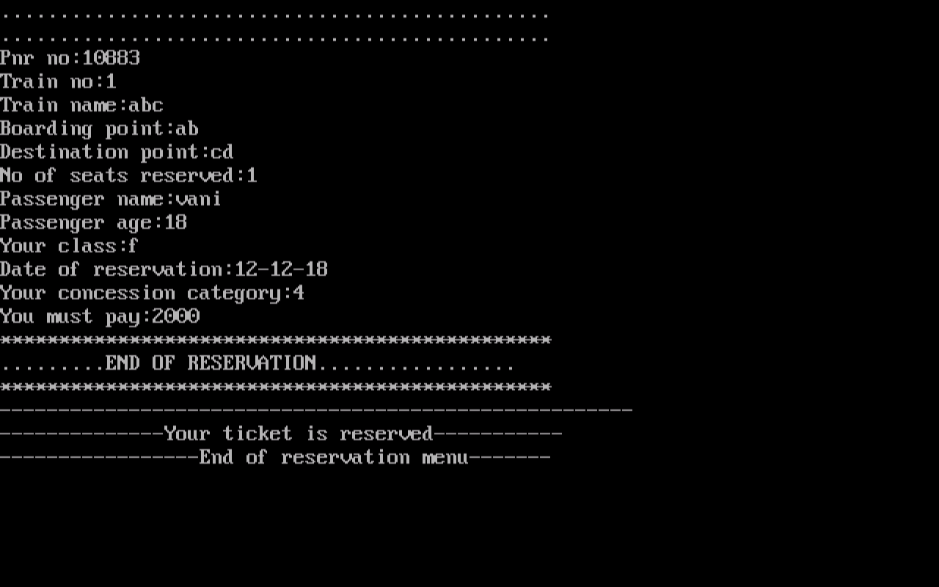

1. CANCEL TICKET

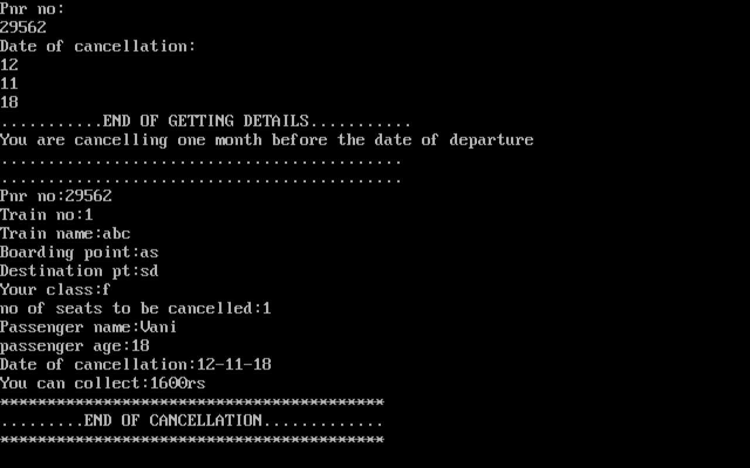

1. TRAIN ENQUIRY



FUTURE SCOPE OF THE PROGRAM

The program made on RAILWAY RESERVATION SYSTEM is made and designed in such a way that it depicts the real world scenario. The program works in the same way the railway tickets are reserved at the railway counter. By the help of this program we can reserve and cancel railway tickets. In future, this program can be modified and redesigned in a way that people can reserve and cancel tickets online through a mobile application. The payments can be done by net banking, e-wallet, etc. In this way, the efficiency and accuracy of the present railway reservation system can be improved and can be made user friendly.

BIBLIOGRAPHY

1. Computer Science with Sumita Arora
2. https://www.google.co.in
3. https://www.wikipedia.org/
4. https://www.codesdope.com